Mercer University Capstone Project

Seth Colston

INFM 482 – Professor Long

Executive Summary

This project was the creation of a website redesign for a company called XiangTea (Xiang Herbs & Tea). This company had an original website designed by me, and this original site was very sub-par. In their efforts for rebranding, I have created them a whole new modernized site including key online shopping features with a customer login/sign up feature. With the overhaul of the old site there were lots of things that took a while to get upgraded, but over time I was able to do a complete a great transformation and the client is very pleased with the results. The site is a full-stack site with front and back-end connections and features. All data entered on the website is entered into various database tables to collect the information of shoppers and account holders. These features were put to the test by me and a few volunteers to ensure that everything was working as it should. The volunteers helped me find a major and minor error in my design. This is why it is important to have others test your product before you have the final product.

Mercer University Capstone Project

XiangTea is a family business that includes an online organic herb & tea store. They also have an organic Farm in Loganville GA. Their family has 3 generations of herbalists. In the online store we only provide USDA certified organic herbs and tea. In their organic farm they also grow diverse seasonal herbs and new tea flavors year-round which we sell to local customers. They have overgrown their original site and wanted to start selling more online to expand their audience. During this transition they are also doing a re branding of their logo to match the new website. Bringing their business online will allow them to grow and reach a wider scale of people.

# Background and Motivation

With their recent growth, they would like to remodel their brand and expand to a newer website with online shopping and account access ability. This would help them expand along with a complete rebranding and overhaul of their current site. Their current website design is very basic and more of a prototype. There is no back-end ability on the site and is only basic front-end development. The goal is to create a fully functional full-stack website for XiangTea. This website will give them a huge upgrade from their previous site design, but also help with their rebranding and recent growth online.

## Problem Statements and Objectives

The main objective is to transform and to create a modernized designed website that flows and functions like a real website. When creating the site from the old design, the new design will have a much better layout and functionality. This will show how far they have come from their old site. The redesign of their site will add a more modern design (and colors) to match their rebranding. The main system components include a login feature, a sign-up feature, and a working shopping cart where you can add and remove items. The creation of accounts will allow XiangTea to keep track of repeat customers and allow new people to become members and receive benefits.

### Project Design and Implementation.

The new site will be created using HTML, CSS, PHP, Bootstrap and JS. The new design involves bootstrap packages and layout along with imported JS packages/scripts to add different design features and interactivity to really make the website active. Most of the pages will be created using PHP for functionality and allow a connection to PhpMyAdmin to pull database information using SQL & PDO connections. The new design involves a new color scheme using pastel colors to really give the “modern” tea vibe. There was some inspiration for the design based off other tea websites found online (Art of Tea, 2023). Any user can visit the website and create an account if they would like to, they can also sign-up for newsletters, leave a review, log in to their accounts, and shop for teas and purchase them.

Old Design:

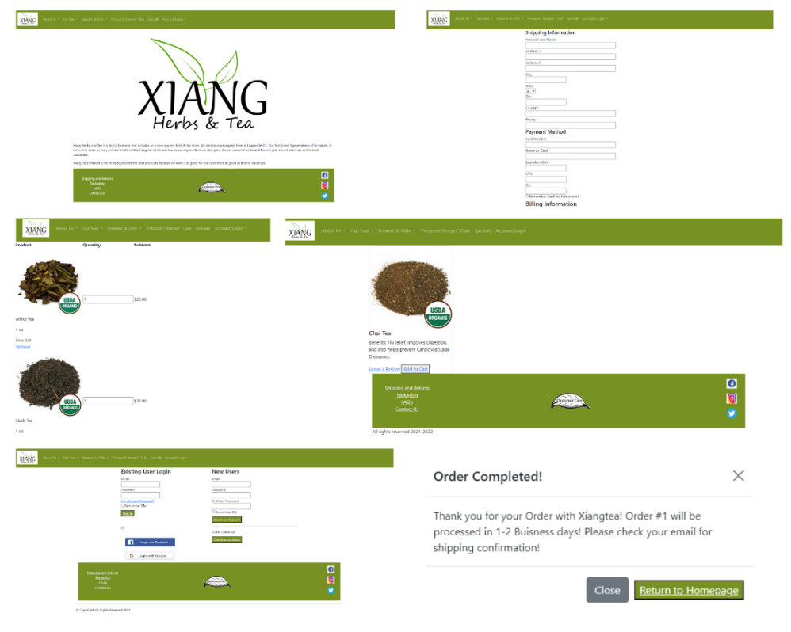

New Design:

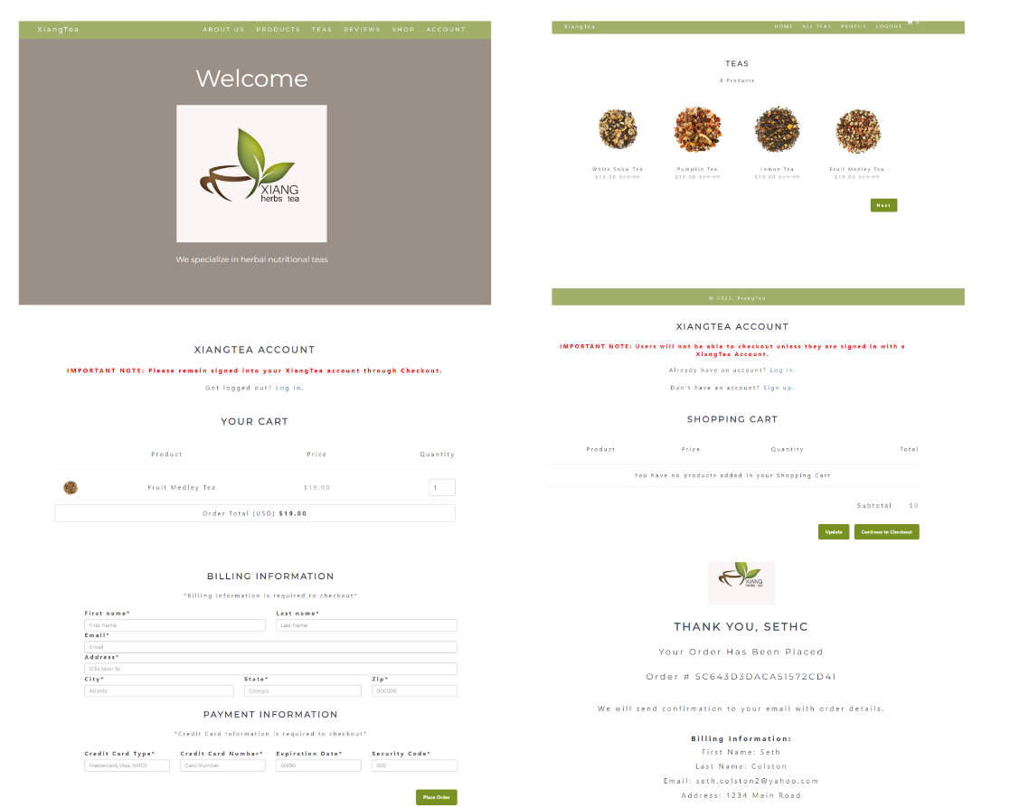

For this to be a full-stack website, the site needed to have connections to a backend database that caught and stored all the information shoppers would enter. The database connected involved SQL and PDO connections to PhpMyAdmin database software. In this database there are tables for: accounts, orders, products, reviews, and subscribers. Each of these tables involves different data and are tied to different functional pieces found on the site.

The accounts table is used to store user information that is entered to create an account. This involves a username, password, and email address. The user can use any information they want when creating an account, and once they do that the information is stored on the accounts table where they can login afterwards. Once a user logs in, they are then taken to the account portion of the site, where they can view their account details, shop, or even logout and create another account. However, the data stored in the database is checked automatically upon entry, so you can only use an email one time.

Login/Signup feature and profile w/ accounts table:

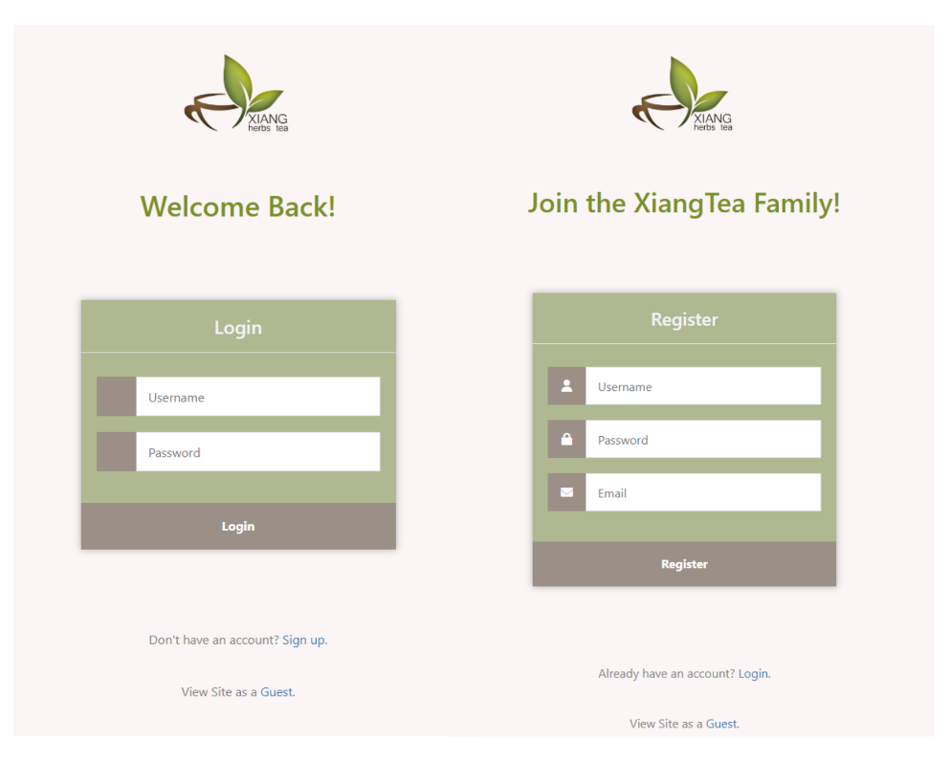

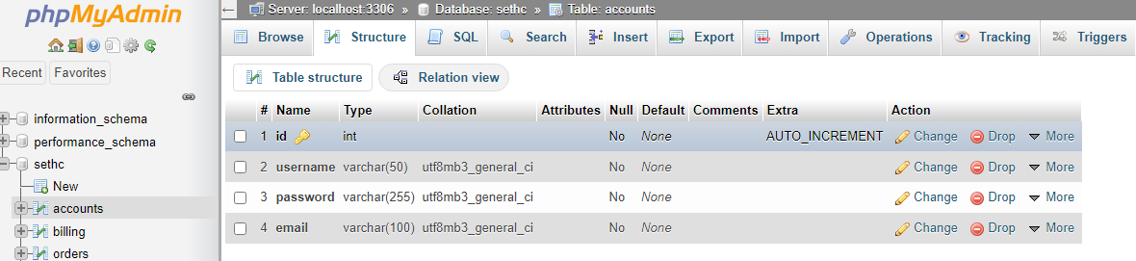

Next on the site is the products table. Everything in this table is tied to the shopping cart feature and checkout functionality of the website. Each product has its own page with a picture and short description about each one. You can add the products and remove them from the cart page. From the cart, you can view your account profile and even create a new account if you wanted. You can also add and remove products from the cart and if you change the desired quantity all you must do is click update and it will re-calculate your total. Once you click the continue to checkout button, you will be brought to the next page.

Cart home, products, product, and cart page w/ products table:

The checkout page is tied to the account, products, and orders table. From here, a shopper must enter their address along with their credit card information. Once the user has filled out all the necessary information to checkout, they then click the place order button to confirm their order. Once this is done, their information, along with whatever products and their quantities, is entered into the orders table. The user must have an account to checkout, in doing this it captures the user’s account ID and ties it to the order. The idea of this is that in the future to create a way for a user to view their previous orders, but for right now it just ties it to the account table for the backend. Upon every time a user checks out, they are given a random transaction ID on the backend, and this is displayed the order number. This number is unique for every order, so that they are easily separated from the back-end table. From the checkout page, the user is then re-directed to the place order page. On the place order page, it thanks a user by their account username, displays their order number, and then also displays what billing information was entered. If there are any discrepancies with the billing and shipping information the user can reach out to customer service with their order number to get this corrected. Both the checkout and place order page are connected to the orders table.

Checkout page:

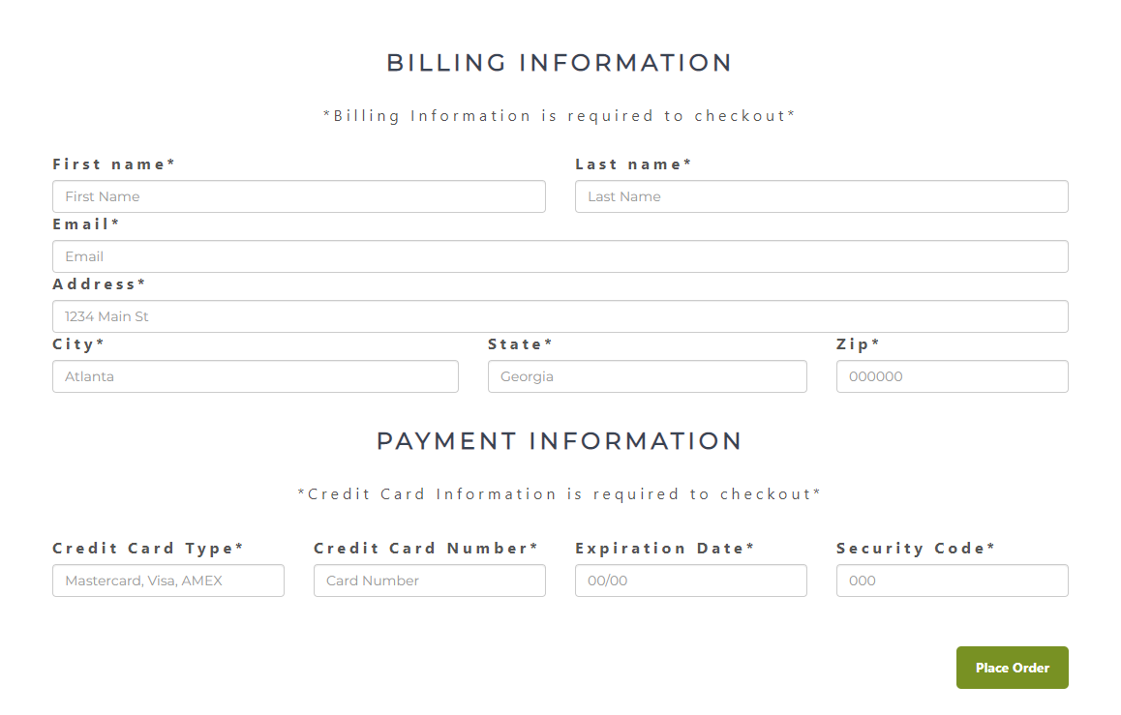

Place order page w/ order table:

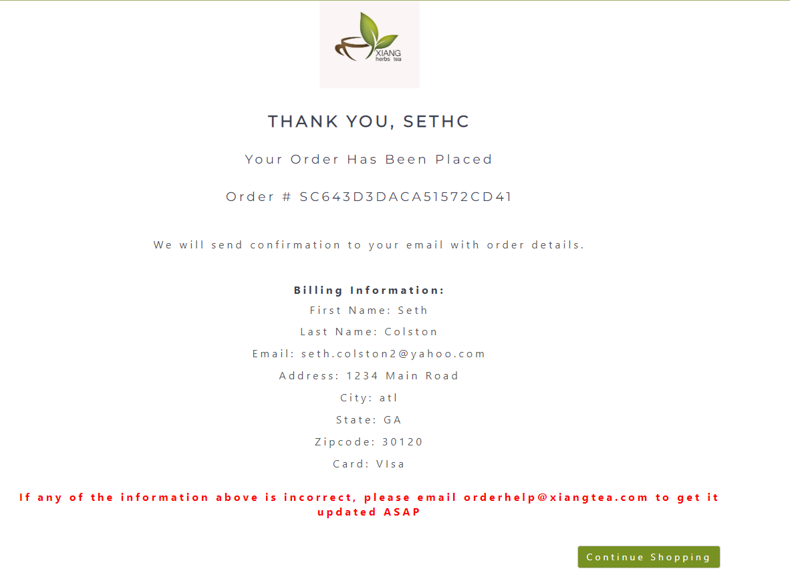

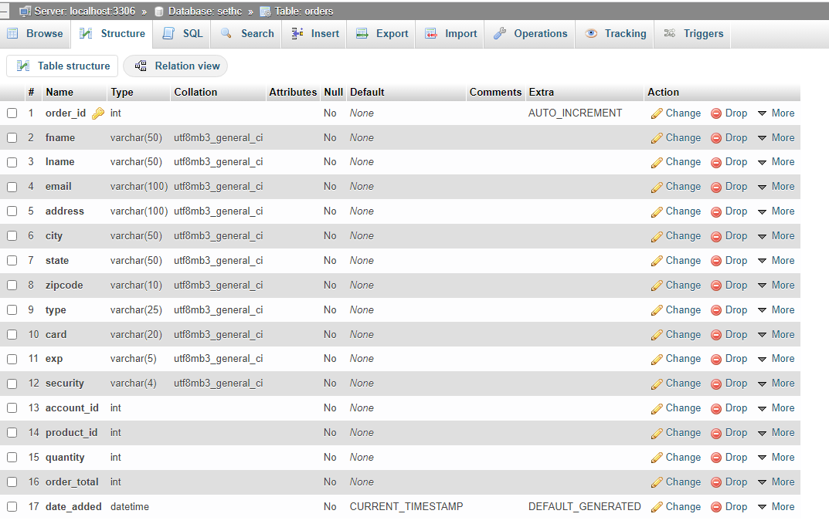

The reviews table displays information differently from the others, this is done by using JavaScript functions. This was to ensure that all data entered would be displayed correctly without any errors. From the home page, a user can go down to reviews and read previous reviews or even leave their own review. All reviews entered are captured at the exact time they were entered and are displayed in the newest to oldest review. If a user enters a lower star rating, JavaScript will calculate the new average star rating.

Reviews page w/ reviews table:

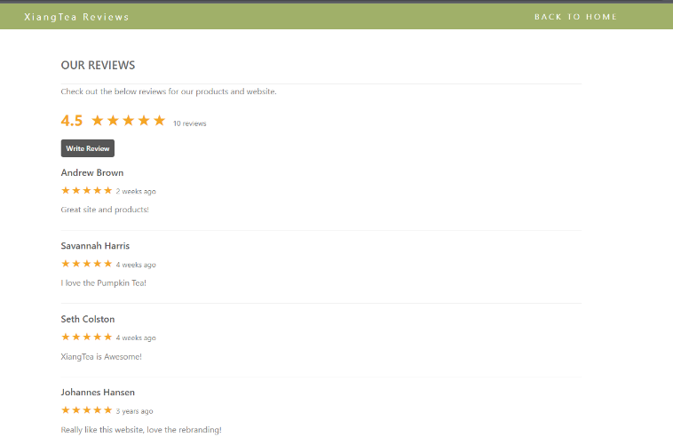

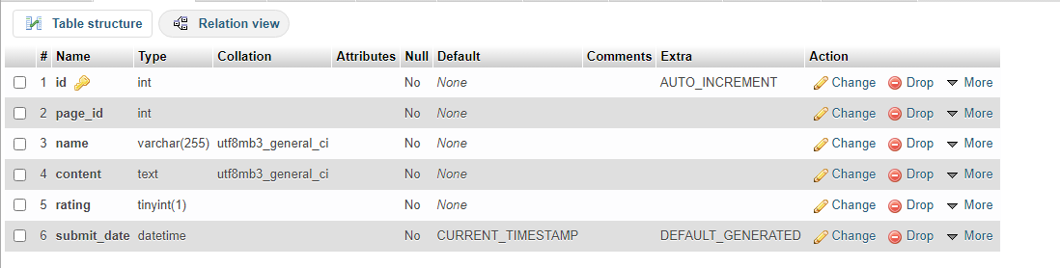

Lastly is the subscriber’s table. This table captures anyone’s email, even if they are just viewing as a guest and imports it into the subscriber’s table. In doing this, XiangTea can send their newsletter marketing emails to this group of people, to keep them up to date on the newest products. The table does test the email before entering it into the database, and if there is already that email subscribed to newsletters, you will get an error message that the email has already been used. This keeps the table free of duplicated email addresses.

Newsletter signup w/ subscribers table:

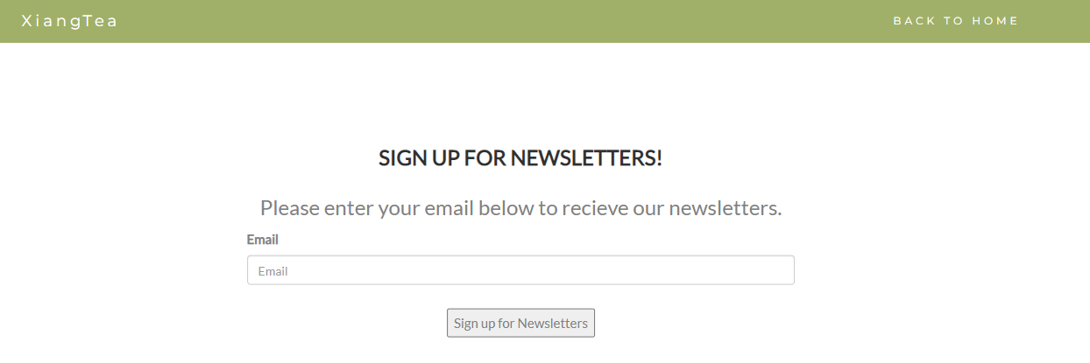

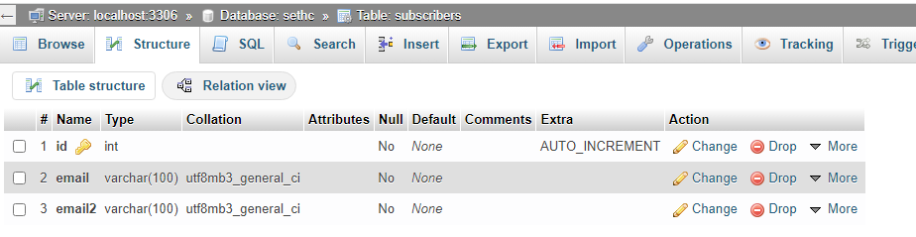

#### Testing, Evaluations, and Validations.

My original focus was to ensure the front-end design will meet the objective of the client. After the color pallet was approved, the design and layout were created. The first goal was to make all information easily accessible. This was implemented by giving the website a scroll feature on the home page. The next step was to ensure that each different page flowed together. Whether they are getting information about the company or purchasing products, the site had to create a smooth navigation between all pages. To make sure my new site layout was flowing properly I had a few volunteers go through my site and give me feedback on what they thought I should implement or change.

One of the biggest flaws to my original design was located on the cart page, and I didn’t notice it until one of the volunteers pointed out the flaw in my design. When user’s checkout, they are required to be signed into a XiangTea account to help with capturing orders, but nowhere on the cart page or cart home did it say this. The only page it said this on was the checkout page, but a user could only go to the next page after entering all their information and being logged in. To fix this major flaw, I added a sign up and login link to the cart page along with a message stating the user must be signed into checkout. From there I revised the checkout page wording and finalized this design. I would have never caught that without someone trying to use the site themselves.

Another flaw that was caught were a few grammatical errors that were found throughout the site. From wrong punction or run-on sentences, all these errors were located and corrected. This was also found by a usability tester, who was also a teacher!

When creating additional things, a visitor could do on the site I added a newsletter signup feature along with a review feature. To make the review feature work I had to make sure the JavaScript functions worked correctly. After adding the shopping feature to the site, I had initial issues making sure the CSS is formal across all pages and the same scheme is applied to each page. This was done to ensure the overall design is eye-catching, and not create any confusion for the customer. With the shopping cart feature it was a necessity to make sure the functions added orders to the backend database. This was to help XiangTea keep track of previous orders to make sure they are all fulfilled. This is one of the biggest features that was not on their old site.

Lastly, there will need to be a login and sign-up feature added to the site. These features would allow users to be able to purchase products and access their account information. This includes adding information to a separate database table and pulling this information created and allowing users to log in to their newly created account. After creating an account, users can successfully order products from the store.

##### Discussions/Problems.

There were a couple of challenges when taking on this project. Throughout my years are Mercer I have learned a lot about website and app building, but this by far was the biggest challenge I had faced. There was a lot of teaching about front end development and back-end development, along with SQL and database queries, but there was never an instance of putting them all together on a project. For this capstone project I had to take what I had learned and figure out exactly how to put the pieces together. My biggest struggles were creating the processes to get data entered on the site into a table in the database. From there, it took a lot of time to get on the right track, but with the help of YouTube and other sources I got my problems ironed out (Adams, 2023) ( Clever Techie, 2017) (Creating Backend, 2023).

Once I got one database working, it was just about copying the connections over and adjusting the variables per table. The orders table was by far the most difficult. In my original design it was redundant with the products table, so Professor Long had me revise the table to make more sense in a real-world situation. I created a normalized design table to include all the necessary information needed to track orders down and give enough information. For example, if a user orders some tea, it will create an order ID number, a transaction number (“order number”), give you the specific products, order total, date ordered, and the account ID of the person who ordered it.

Start to finish I enjoyed recreating this website for XiangTea. The process was long and there were a lot of testing features, but all the designs are fully functional. XiangTea was also very happy with their new site!

References

Adams, D. (2023b, March 24). *CodeShack - Resource Website for Developers & Designers*. CodeShack. https://codeshack.io/

Adams, D. (2023, March 17). *Shopping Cart System with PHP and MySQL*. CodeShack. https://codeshack.io/shopping-cart-system-php-mysql/

Art of Tea. (2023). *Organic Loose Leaf Teas, Tea Bags & Tea Gift | Art of Tea*. https://www.artoftea.com/

*Bootstrap 3 Tutorial*. (n.d.). https://www.w3schools.com/bootstrap/

Clever Techie. (2017, December 24). *Responsive PHP Shopping Cart with Bootstrap Tutorial* [Video]. YouTube. <https://www.youtube.com/watch?v=YvXaKDnHKVk>

*Creating Backend Routes and User Model for Login and Signup in MEAN Stack - javatpoint*. (n.d.). www.javatpoint.com. https://www.javatpoint.com/creating-backend-routes-and-user-model-for-login-and-signup-in-mean-stack

Daily Tuition. (2019, June 14). *Advanced Shopping Cart Tutorial With Php and MySqli Database* [Video]. YouTube. https://www.youtube.com/watch?v=eAK8uYtNTy4

Programming With Dickson. (2021, February 16). *How To Create Simple Shopping Cart Using PHP And MySQL* [Video]. YouTube. https://www.youtube.com/watch?v=YloyMFPJyV4

Zameer, A. (2021, April 29). *PHP Shopping Cart - Step by Step - WDB24*. WDB24. https://www.wdb24.com/php-shopping-cart-step-by-step/?amp=1